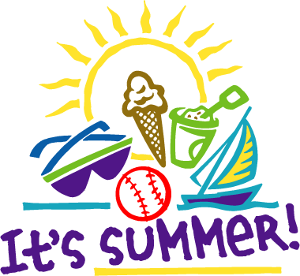 | June 2016

Mon. | Tue. | Wed. | Thu. | Fri. | Sat. | Sun.
 |  | 1 | 2 | 3 | 4 | 5
6 | 7 | 8 | 9 | 10 | 11 | 12
Field Trip-Farmington Water Park | Pool  Pop Up Book  Foods-Ms. Miller-Ice Cream and Smootie | Pop Up Book  Makey Makey | Pool  Makey Makey | Special Needs project
13  F | 14 | 15 | 16 | 17 | 18 | 19
Field Trip | Pool  Discipline and Attendance  Do’s and Don’ts  Foods-Ms. Miller-Pizza and Tacos | Lockers/ Schedules/ Planners | MOCK Day
20 | 21 | 22 | 23 | 24 | 25 | 26
27 | 28 | 29 | 30

notes | There will be presenters visiting pertaining to snakes and bats

